ShadowFox Cyber Security Virtual Internship Program

Task Report Level (Hard)

BY
Name: GOPICHAND DANDIMENI
Email: GC67766@gmail.com
Batch: Shadow Fox-Cyber Security July B1

Index
TITLE
Basic Pentesting room in the Tryhackme platform

Index Figures
Figure No | Name | Page No
3.2.1 | souce code | 5
3.2.2 | hidden directions | 5
3.2.3 | user names | 6
3.2.4 | jan password | 6
3.2.5 | Kay’s home directory | 6
3.2.6 | passphrase with john | 7
3.2.7 | Logging into Kay’s SSH | 7

Index of Shortcuts
- 3.2.1, 3.2.2. 3.2… =3 level 2nd task 1st image
- SSH = Secure Shell

- Statement
Using the Tryhackme platform, launch the Basic Pentesting room. Penetrate the room and answer all the questions that are given to you on the website and also create a detailed document of the process of penetration and how you did it

- Introduction
The TryHackMe platform offers possibilities for learning some cybersecurity skills, especially penetration tests, in an interesting way while keeping the fun alive. The Basic Pentesting room is made for newbies to understand the most basic tools and techniques used in ethical hacking. Participants challenge themselves on various tasks that simulate real-world practicality, allowing them to improve their hands-on skills. Once a user completes this room, they will have firsthand experience with reconnaissance, exploitation, and privilege escalation. All this is mandatory training for anyone who wants to pursue a line in cybersecurity.

- Information about the report
- Targated Website : Tryhackme(website) Pentesting room
- Purpose: Identify vulnerabilities and retrieve the password.
- Tools used:
- nmap (port scanning)
- gobuster (web directory brute-forcing)
- smbclient (SMB enumeration)
- hydra (SSH brute-forcing)
- ssh2john (private key cracking)
- Date of attack performed :- 12 july 2025

- Attack
Attack name :-
- Web Directory Enumeration
- SSH Brute-Force Attack
- SSH Key Passphrase Cracking
- Severity
It is also know as CVSS (Common Vulnerability Scoring System)
- Score Range: 0.0 – 10.0
Score | Severity Level | Meaning
0.0 | None | No impact.
0.1 – 3.9 | Low | Minor issue (e.g., info leak, non-critical misconfig).
4.0 – 6.9 | Medium | Significant risk (e.g., privilege escalation, DoS potential).
7.0 – 8.9 | High | Serious risk (e.g., RCE, SQLi, authentication bypass).
9.0 – 10.0 | Critical | Immediate threat (e.g., wormable exploits, system compromise).

The Severity scoring of Tryhackme(website) Pentesting room
- Attack Name: Web Directory Enumeration
4.0 – 6.9 | Medium | Significant risk (e.g., privilege escalation, DoS potential).

- Attack Name: Weak Password Compromise
9.0 – 10.0 | Critical | Immediate threat (e.g., wormable exploits, system compromise).

- Attack Name: SSH Key Passphrase Cracking
7.0 – 8.9 | High | Serious risk (e.g., RCE, SQLi, authentication bypass).

- Impact
- Attack Name: Web Directory Enumeration
The exposed development directory was found to lead to sensitive files that revealed weaknesses in the system and valid usernames jan and kay. Such information leak, then built the basis on which subsequent attacks were conducted like SSH brute-forcing and privilege escalation. This vulnerability has a medium severity denoting that it is classified as CVSS 5.3, the real danger of compromising the targeted system completely by opening attack vectors that should have been secured.
- Exposure of Sensitive Information
- Discovered files (dev.txt, j.txt) revealed:
- System misconfigurations (weak security settings).
- Valid usernames (jan, kay) and hints about weak passwords.

- Attack Name: Weak Password Compromise
From the unauthorized initial access on, the intrusion supported by the brute-force attack with weak credentials (Username: jan, Password: armando) took place on the SSH service. Having gained an initial foothold, the attacker was free to enumerate the system and eventually discover the private SSH key of kay. The compromise utilized weak password policies as a critical security gap allowing the attacker to bypass authentication controls with minimal effort. Being considered Medium, the attack was raised to High due to its involvement in later attacks that led to privilege escalation and thus total compromise of the system. This incident emphasizes the need for strong passwords and other mitigations against that, such as multi-factor authentication or account lockout policies.
- Attack Name: SSH Key Passphrase Cracking
The compromise of kay's weak SSH key passphrase (beeswax) led to almost total systems compromise with very rich administrative control. This high level breach enables the theft of sensitive data, manipulation of systems, and potential access across the network. The vulnerability illustrated serious failures in protection of cryptographic keys, wherein a single weak passphrase could break every security measure. This could cause dramatic outcomes in possible data deletion, ransomware attacks, or permanent backdoor installations into production environments. The severity of the attack was worsened due to the inherently permanent nature of key-based access which is impervious to change in passwords. Strong key passphrases as well as good key management practices in all systems should therefore be really emphasized.

- Steps to Reproduce
- Login in Basic Pentesting room on TryHackMe
- Start the machine and connect to network
- Find the services exposed by the machine to find open ports
nmap -sC -sV -oN nmap -p- <10.10.137.72>
Flags expiation
- -sC → Runs default Nmap scripts (equivalent to –script=default).
- -sV → Version detection (identifies services running on open ports).
- -oN nmap → Saves the results in normal output format to a file named nmap.
- -p- → Scans all 65,535 ports (instead of just the top 1,000).
- <target ip> → The target IP address you want to scan.
- The question required to solve by finding hiden flag to slove that question the following Questions are
- What is the name of the hidden directory on the web server(enter name without /)?
When we see source code 10.10.137.72
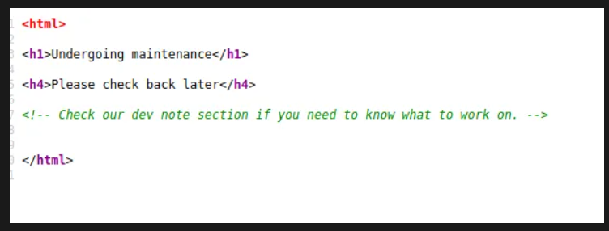
Fig-3.2.1(souce code)
to find hidden directories by using gobuster I used gobuster dir -w /usr/share/wordlists/dirbuster/directory-list-2.3-medium.txt -u <target ip>
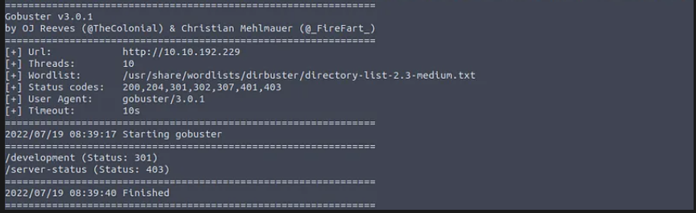
Fig-3.2.2(hidden directions)
You can see 2 directories with status any one from this will be the answers
Answer: development
- User brute-forcing to find the username & password
When you access to development page you will see dev,txt & j.tex
For port scanning to discored SMB use enum4linux < 10.10.137.72>
You will see the user name in output
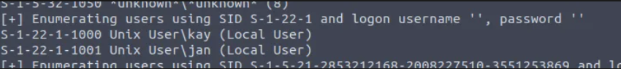
Fig-3.2.3(user names)
To bruteforce Jan’s account with Hydra we use hydra -l jan -P /usr/share/wordlists/rockyou.txt ssh://< 10.10.137.72>
Fig-3.2.4(jan password)
- What is the username?
Answer: jan
- What is the password?
Answer: armando
- What service do you use to access the server(answer in abbreviation in all caps)?
Answer: SSH
- Enumerate the machine to find any vectors for privilege escalation
To login in to login with SSH we can use ssh jan@< 10.10.137.72>
Now you can get into Kay’s home directory
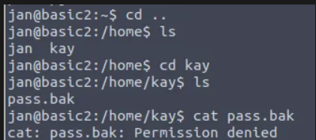
Fig-3.2.5(Kay’s home directory)
- What is the name of the other user you found(all lower case)?
Answer: kay
- If you have found another user, what can you do with this information?
To run john john john_hash.txt --wordlist=/usr/share/wordlists/rockyou.txt
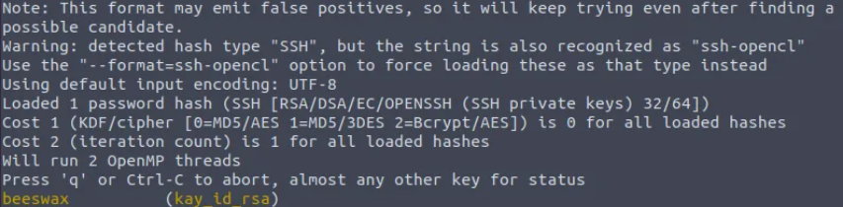
Fig-3.2.6( c)
You Login now
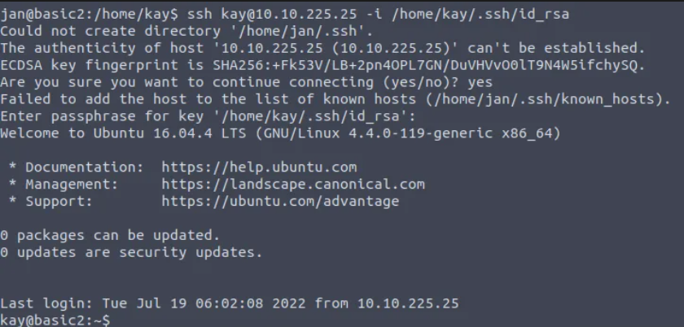
Fig-3.2.7( Logging into Kay’s SSH)
- What is the final password you obtain?
The final password obtain is earlier founded in vulnerability in the vim executable. In file of /Home/kay/.ssh/ID_RSA
Answer: heresareallystrongpasswordthatfollowsthepasswordpolicy

- Mitigation Steps
- Restrict Directory Access
Prevent unauthorized access to sensitive folders with .htaccess/server configurations.
- Disable Directory Listing
The index should be disabled in the web server settings for files/folders to be invisible.
- Remove Sensitive Files
Forget developer notes, backup files, or any credentials from off-production servers.
- Implement Web Application Firewall (WAF)
Tools like ModSecurity must be employed to block any automated scans or attacks.
- Enforce Strong Password Policies
Require 12 or more characters with symbols/numbers + enforce MFA.
- Regular Password Audits
Assess password strength using Hashcat/John the Ripper.
- Use Strong Passphrases for SSH Keys
Secure the private key with a passphrase of at least 20 characters + apply appropriate file permission restrictions

- References and Resources Used
- Web Directory Enumeration
- OWASP Directory Traversal Guide: https://owasp.org/www-community/attacks/Directory_traversal
- Apache .htaccess Security: https://httpd.apache.org/docs/2.4/howto/htaccess.html
- ModSecurity (WAF): https://github.com/SpiderLabs/ModSecurity
- Weak Password Compromise
- NIST Password Guidelines: https://pages.nist.gov/800-63-3/sp800-63b.html
- Fail2Ban (Brute-Force Protection): https://www.fail2ban.org
- Google Authenticator (MFA): https://github.com/google/google-authenticator
- SSH Key Passphrase Cracking
- OpenSSH Hardening Guide: https://www.ssh.com/academy/guides/ssh-hardening
- John the Ripper (Password Cracking): https://www.openwall.com/john
- Linux File Permissions: https://linuxize.com/post/chmod-command-in-linux
- General Cybersecurity Standards
- OWASP Top 10: https://owasp.org/www-project-top-ten
- MITRE ATT&CK Framework: https://attack.mitre.org
- CVSS Scoring (Severity Metrics): https://www.first.org/cvss

